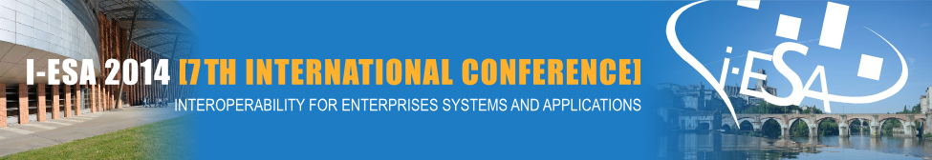



I-ESA’14

CALL FOR WORKSHOP PROPOSALS

INTEROPERABILITY FOR ENTERPRISE SYSTEMS AND APPLICATIONS “INTEROPERABILITY FOR AGILITY, RESILIENCE AND PLASTICITY OF COLLABORATIONS”
March 24th-28th, 2014 – ALBI (FRANCE)

I-ESA brings together the world’s leading researchers and practitioners in the area of Enterprise Interoperability for the development of new Enterprise solutions based on the Internet of the Future. Initiated in 2005 by two major European research projects of the FP6 of the European Commission, the ATHENA IP (Advanced Technologies for Interoperability of Heterogeneous Enterprise Networks and their Applications, Integrated Project) and the INTEROP NoE (Interoperability Research for Networked Enterprise Applications and Software, Network of Excellence), the I-ESA conferences have been recognized as a tool to lead and generate an extensive research and industrial impact in the field of interoperability for enterprise software and applications. I-ESA'2014 will be held in Albi, France by 24th-25st March, 2014 (Pre-conference) and 26nd-28rd March, 2014 (Conference): www.i-esa.org
Workshops should explore new issues (such as Servitisation, Enterprise Interoperability and innovative solutions) and should concentrate in-depth on research topics, or may also be devoted to application and/or standardization issues or road mapping activities or concrete description of funded project results.
Workshops are meant to facilitate the exchange of ideas and experiences between researchers and stimulate discussions on emerging issues. The workshop must include time for brainstorming and discussions between attendees to conclude to new research directions.
Workshops should address specific challenges and new issues within the scope of Enterprise Interoperability. They should aim at presenting and discussing concrete intermediate or complete results of research projects and case studies that may guide future work. Suggested fields of interest are:
- Enterprise Interoperability (EI) in the service domain
- New approaches in the frame of MDI and MDSEA
- Cloud computing and Web based enterprise services for EI
- Case studies and experience reports on interoperability solutions
- Standardisation for enterprise interoperability - New approaches and implementations
- …
If you are interested in organising a workshop during the I-ESA'2014 conference, submit your proposal (by using the form hereinafter) to the Workshops Chair: ws-chair@i-esa.org
Important dates:
- Workshop proposals due: September 13th, 2013
- Notification of acceptance: October 5th, 2013
- Workshops call for papers: October 15th, 2013
- Workshop deadline for papers: December 20th, 2013
- Workshops Programme: January 31th, 2014
- Workshops Venue: 24th - 25st March, 2014.
Template to describe the Workshop proposal (2-3 pages) – I-ESA 2014
1. Workshop title
2. Information about the organiser (s)  Please include name and contact details of each organizer, and indicate his/her relevant background and area of interest. | Name:  First name:  Organisation:  Sector activity:  Country:  Email:  Phone number:  Research interests and areas of expertise:
3. Objective
Goals of the workshop, content and topics covered
4. Format (draft)
Number of speaker s/ papers, invited presentations or panels, discussions, debates, Other methods to encourage communication and consensus?
Half-day or full day?
5. Publicity
How will the WS be advertised?
6. Audience
How many participants are expected and what is their background?
7. Workshop call for papers (tentative)
with the proposed members of the Program Committee. Workshop organisers have to set up a peer review of the proposed papers

Workshops Chair: Matthieu Lauras, Mines Albi, FR

Workshop co-Chair: Martin Zelm, INTEROP-VLab, BE

Workshops Committee Members:
- Yves Ducq, University Bordeaux 1, FR
- Stephan Kassel, University of Applied Sciences Zwickau, DE
- Elise Vareilles, Mines Albi, FR
- Anne-Marie Barthe-Delanoë, Mines Albi, FR

